Eye Anatomy: Parts of the Eye

PHD. Professional. Mohammed A. Ali
Department of Anatomy, Histology and Embryology, College of Veterinary Medicine, University of Basra, Basra, Iraq.
The eye is composed of three primary concentric layers (tunics) surrounding the fluid-filled interior: the outer fibrous layer (sclera/cornea), the middle vascular layer (uvea: iris/ciliary body/choroid), and the inner nervous layer (retina). These layers protect the eye, focus light, and convert visual stimuli into neural signals for the brain.
The eye is composed of three primary concentric layers (tunics):-
1. Outer Layer (Fibrous Tunic)
Sclera: The opaque, white posterior portion that maintains the eye's shape and provides structural protection.
Cornea: The transparent, dome-shaped anterior portion that covers the iris and pupil, functioning as the eye's primary light focuser.
American Academy of Ophthalmology
2. Middle Layer (Vascular Tunic or Uvea)
Iris: The colored part of the eye that contains muscles to constrict or dilate the pupil, regulating light intake.
Ciliary Body: Produces aqueous humor and contains muscles that adjust the shape of the lens for focusing.
Choroid: A highly vascularized layer providing oxygen and nourishment to the outer layers of the retina.

3. Inner Layer (Neural Tunic or Retina)
Retina: Contains photoreceptor cells (rods and cones) that detect light and convert it into neural signals.
Retinal Pigment Epithelium (RPE): A specialized layer between the sensory retina and the choroid that absorbs stray light and supports photoreceptor function.

The eye is a complex sensory organ that captures light and converts it into visual signals for the brain, utilizing key structures like the cornea, iris, pupil, lens, and retina to focus images. It is housed in the orbit for protection, with photoreceptor cells (rods and cones) enabling sight..

Anatomy and Functions

Cornea & Sclera: The cornea acts as the eye's outer windshield, focusing light, while the sclera provides the structural white outer layer.

Iris & Pupil: The iris controls the amount of light entering by adjusting the pupil, which acts as an adjustable window.

Lens: Located behind the iris, it changes shape to focus light on the retina, allowing for clear vision at varying distances.

Retina: Contains rods (shapes) and cones (color) that convert light into electrical signals.

Optic Nerve: Transmits visual information from the retina to the brain.

Vitreous Humor: A gel-like substance that fills the center of the eye to maintain its shape.
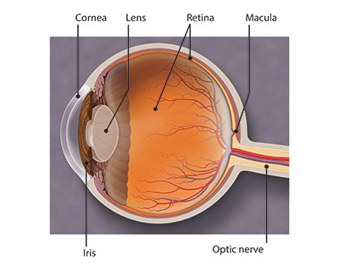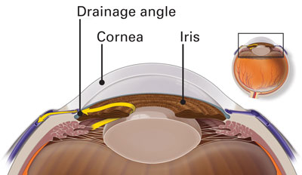

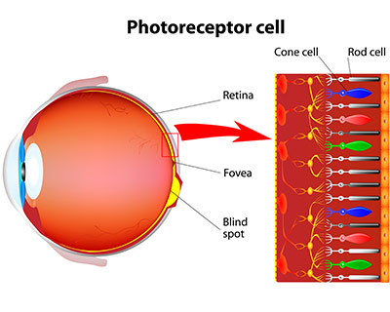The retina has special cells called photoreceptors. These cells change light into energy that is transmitted to the brain. There are two types of photoreceptors: rods and cones. Rods perceive black and white, and enable night vision. Cones perceive color, and provide central (detail) vision.
The retina sends light as electrical impulses through the optic nerve to the brain. The optic nerve is made up of millions of nerve fibers that transmit these impulses to the visual cortex — the part of the brain responsible for our sight.
The Eye Muscle
The eye is controlled by seven main muscles: six extraocular skeletal muscles that move the eyeball and eyelids, and internal involuntary muscles. The extraocular muscles include four recti (superior, inferior, medial, lateral) and two obliques (superior, inferior), which enable precise, coordinated movements. They are responsible for elevating, depressing, rotating, and turning the eye, as well as lifting the eyelid.

Extraocular Muscles (Movement)
Superior Rectus: Elevates the eye, contributes to inward rotation (intorsion) and adduction.

Inferior Rectus: Depresses the eye, contributes to outward rotation (extorsion) and adduction.

Medial Rectus: Moves the eye medially toward the nose (adduction).

Lateral Rectus: Moves the eye laterally away from the nose (abduction).

Superior Oblique: Depresses, abducts, and rotates the eye inward (intorsion).

Inferior Oblique: Elevates, abducts, and rotates the eye outward (extorsion).

Levator Palpebrae Superioris: Lifts the upper eyelid.

Internal (Intrinsic) Muscles (Focus and Light)
Ciliary Muscle: A ring of smooth muscle that changes the shape of the lens for focusing (accommodation).

Sphincter Pupillae: Constricts the pupil in bright light.

Dilator Pupillae: Dilates the pupil in low light.

Innervation (Nerves)

Oculomotor Nerve (CN III): Controls the superior, inferior, and medial recti, as well as the inferior oblique and levator palpebrae superioris.

Trochlear Nerve (CN IV): Controls the superior oblique muscle.

Abducens Nerve (CN VI): Controls the lateral rectus muscle.

The 10 Layers of the Retina (Outermost to Innermost)
- Retinal Pigment Epithelium (RPE): A single layer of cells that supports photoreceptors, absorbs stray light, and maintains the blood-retinal barrier.
- Photoreceptor Layer: Contains the outer and inner segments of rods (dim light) and cones (color/bright light).
- External Limiting Membrane (ELM): A boundary formed by junctions between Müller cells and photoreceptor cells.
- Outer Nuclear Layer (ONL): Contains the cell bodies (nuclei) of the rod and cone photoreceptors.
- Outer Plexiform Layer (OPL): Contains synapses between photoreceptor cells and neurons in the inner nuclear layer.
- Inner Nuclear Layer (INL): Contains the cell bodies of bipolar, horizontal, and amacrine cells, which process visual signals.
- Inner Plexiform Layer (IPL): Synapse layer where bipolar cells connect with ganglion cells.
- Ganglion Cell Layer (GCL): Contains the cell bodies of ganglion cells, which send visual signals to the brain.
- Nerve Fiber Layer (NFL): Composed of ganglion cell axons that form the optic nerve.
- Inner Limiting Membrane (ILM): The innermost layer, forming a boundary between the retina and the vitreous humor.

With Best Wishes

